2025-944:Sweaters Price：Fob China $2.65 /piece

序号 | style number | photos | fabric | size |  |  |  |  |  | quantity
 |  |  |  | 165/84A | 170/88A | 175/92A | 180/96A | 185/100A | 190/104A | quantity
 |  |  |  | 46 | 48 | 50 | 52 | 54 | 56 | quantity
1 | HNZAD1D021A/21F | 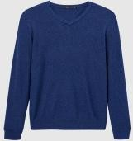 | 50% viscose  40% polyester  10% nylon | 1478 | 3536 | 3725 | 2052 | 1189 | 53 | 12033
2 | HNZAD3D196A/K7C | 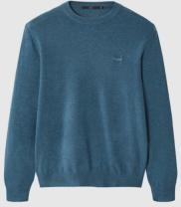 | 50% polyester  36% acrylic  14% nylon | 1982 | 6487 | 7018 | 4399 | 2110 | 451 | 22447
3 | HNZAD3D196A/K6C | 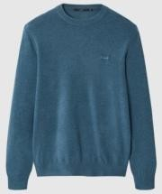 | 50% polyester  36% acrylic  14% nylon | 899 | 3248 | 2044 | 570 | 140 | 39 | 6940
4 | HNZAD1W010A/10L | 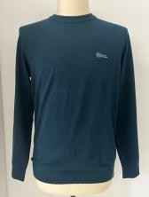 | 58% acrylic27% polyester15% nylon | 216 | 1340 | 2806 | 1949 | 906 | 289 | 7506
7 | HNZAD3U157A/F7L | 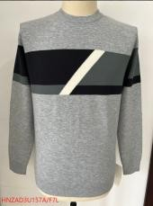 | 主色纱：2/50NM 55% acrylic35% polyester10% nylon辅色纱：2/48NM 50%  viscose 30% polyester20%  acrylic | 737 | 3316 | 2316 | 1280 | 410 | 15 | 8074
8 | HNZAD3U158A/F8L | 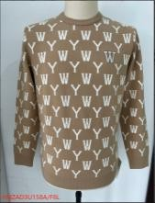 | 58% acrylic27% polyester15% nylon | 133 | 594 | 848 | 1415 | 612 | 35 | 3637
9 | HNZAD1U021A/21C | 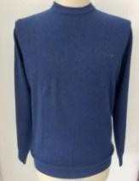 | 58% viscose  25% polyester  17% nylon | 93 | 695 | 972 | 466 | 145 | 9 | 2380
10 | HNZAD1U022A/22C | 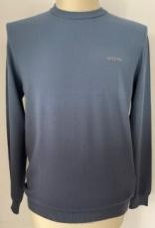 | 66% viscose  34% polyester | 277 | 1401 | 2061 | 1109 | 579 |  | 5427
11 | HNZAD1Y028A/28L | 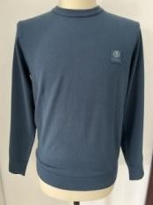 | 58% acrylic  27% polyester  15% nylon | 436 | 608 | 104 | 13 | 7 |  | 1168
15 | HNZAD3Y110/B0L | 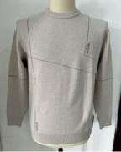 | 58% acrylic27% polyester15% nylon | 837 | 1585 | 1899 | 958 | 261 | 4 | 5544
 | total |  |  |  |  |  |  |  |  | 75156

